Experiment 9
Name : Varad Satish Nashikkar
Roll No : 42454

Index.html :
<!DOCTYPE html>
<html lang="en">
<head>
<meta charset="UTF-8">
<meta name="viewport" content="width=device-width, initial-scale=1.0">
<title>Student Information Form</title>
<link rel="stylesheet" href="styles.css">
</head>
<body>
<div class="container">
<h1>Student Information Form</h1>
<form id="studentForm" autocomplete="off" novalidate>
<div class="form-group">
<label for="name">Full Name:</label>
<input type="text" id="name" placeholder="e.g., Soham Phadnis">
<span class="error" id="nameError"></span>
</div>
<div class="form-group">
<label for="address">Address:</label>
<input type="text" id="address" placeholder="e.g., 123 University Road">
<span class="error" id="addressError"></span>
</div>
<div class="form-group">
<label for="city">City:</label>
<input type="text" id="city" placeholder="e.g., Pune">
<span class="error" id="cityError"></span>
</div>
<div class="form-group">
<label for="state">State:</label>
<select id="state">
<option value="">-- Select State --</option>
<option value="Andhra Pradesh">Andhra Pradesh</option>
<option value="Arunachal Pradesh">Arunachal Pradesh</option>
<option value="Assam">Assam</option>
<option value="Bihar">Bihar</option>
<option value="Chhattisgarh">Chhattisgarh</option>
<option value="Goa">Goa</option>
<option value="Gujarat">Gujarat</option>
<option value="Haryana">Haryana</option>
<option value="Himachal Pradesh">Himachal Pradesh</option>
<option value="Jharkhand">Jharkhand</option>
<option value="Karnataka">Karnataka</option>
<option value="Kerala">Kerala</option>
<option value="Madhya Pradesh">Madhya Pradesh</option>
<option value="Maharashtra">Maharashtra</option>
<option value="Manipur">Manipur</option>
<option value="Meghalaya">Meghalaya</option>
</select>
<span class="error" id="stateError"></span>
</div>
<div class="form-group">
<label for="gender">Gender:</label>
<select id="gender">
<option value="">-- Select Gender --</option>
<option value="Male">Male</option>
<option value="Female">Female</option>
<option value="Other">Other</option>
</select>
<span class="error" id="genderError"></span>
</div>
<div class="form-group">
<label for="mobile">Mobile Number:</label>
<input type="tel" id="mobile" placeholder="e.g., 9876543210">
<span class="error" id="mobileError"></span>
</div>
<div class="form-group">
<label for="email">Email ID:</label>
<input type="email" id="email" placeholder="e.g., soham@example.com">
<span class="error" id="emailError"></span>
</div>
<button type="submit" class="btn">Submit</button>
</form>
<div id="result"></div>
</div>
<script src="script.js"></script>
</body>
</html>

Styles.css :
body {
font-family: Arial, sans-serif;
background: #f4f4f9;
display: flex;
justify-content: center;
align-items: flex-start;
padding: 50px 20px;
}

.container {
width: 100%;
max-width: 500px;
background: #fff;
padding: 30px;
border-radius: 12px;
box-shadow: 0 6px 20px rgba(0,0,0,0.1);
}

h1 {
text-align: center;
margin-bottom: 30px;
color: #333;
}

.form-group {
margin-bottom: 20px;
display: flex;
flex-direction: column;
}

label {
margin-bottom: 5px;
font-weight: bold;
}

input, select {
padding: 10px;
font-size: 1rem;
border: 1px solid #ccc;
border-radius: 6px;
outline: none;
transition: border-color 0.3s, box-shadow 0.3s;
}

input:focus, select:focus {
border-color: #0077b6;
box-shadow: 0 0 5px #0077b6;
}

.btn {
width: 100%;
padding: 12px;
script.js :
document.getElementById('studentForm').addEventListener('submit', function(e) {
e.preventDefault();

const clearErrors = () => {
const errorSpans = document.querySelectorAll('.error');
errorSpans.forEach(span => span.textContent = '');
document.getElementById('result').innerHTML = '';
};

clearErrors();

const name = document.getElementById('name').value.trim();
const address = document.getElementById('address').value.trim();
const city = document.getElementById('city').value.trim();
const state = document.getElementById('state').value.trim();
const gender = document.getElementById('gender').value;
const mobile = document.getElementById('mobile').value.trim();
const email = document.getElementById('email').value.trim();

let isValid = true;

if (!name || !/^[A-Za-z\s]+$/.test(name)) {
document.getElementById('nameError').textContent = "Please enter a valid name.";
isValid = false;
}

if (!address) {
document.getElementById('addressError').textContent = "Address cannot be empty.";
isValid = false;
}

if (!city || !/^[A-Za-z\s]+$/.test(city)) {
document.getElementById('cityError').textContent = "Please enter a valid city.";
isValid = false;
}

if (!state || !/^[A-Za-z\s]+$/.test(state)) {
document.getElementById('stateError').textContent = "Please enter a valid state.";
isValid = false;
}

if (!gender) {
document.getElementById('genderError').textContent = "Please select a gender.";
isValid = false;
}

if (!mobile || !/^[6-9]\d{9}$/.test(mobile)) {
document.getElementById('mobileError').textContent = "Enter a valid 10-digit mobile number.";
isValid = false;
}

if (!email || !/^[^\s@]+@[^\s@]+\.[^\s@]+$/.test(email)) {
document.getElementById('emailError').textContent = "Please enter a valid email address.";
isValid = false;
}

const resultDiv = document.getElementById('result');
if (!isValid) {
resultDiv.innerHTML = "<div class='error'>Please correct the errors above.</div>";
} else {
resultDiv.innerHTML = `
<div class='success'>
<h2>Congratulations, ${name}!</h2>
<p>Your information has been submitted successfully.</p>
</div>
`;
document.getElementById('studentForm').reset();
}
});

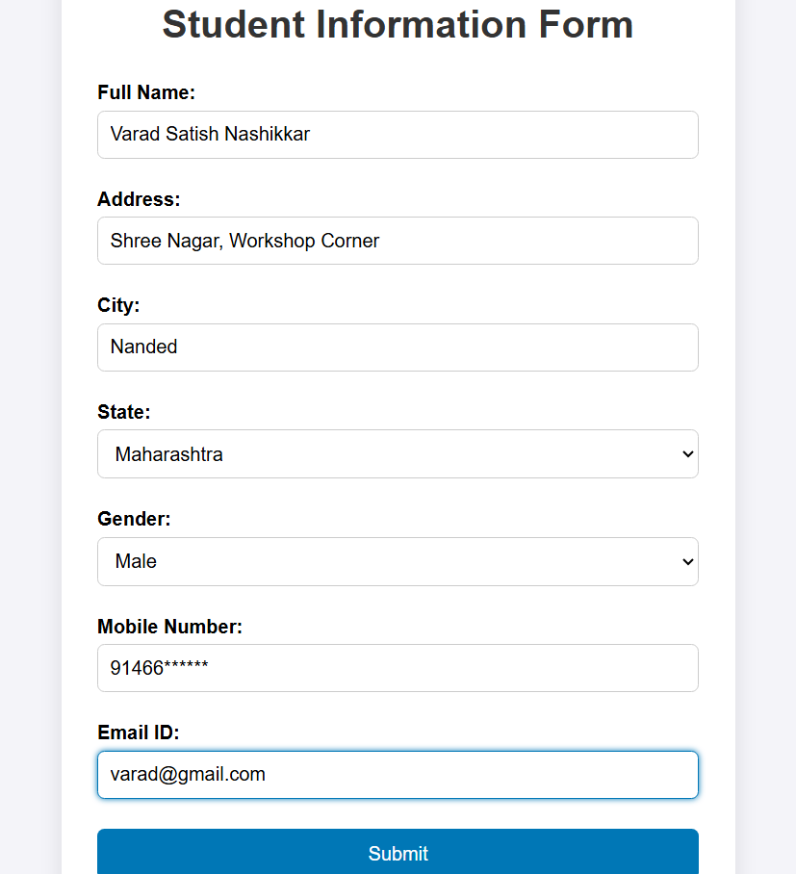
Output :
